SMARTBRIDGE
Let's Bridge the Gap
SKILL WALLET - A SmartBridge Product

Streamlining IT Procurement:
Automating Standard Laptop Orders with Flow Designer
Team ID SWTID-2026-2740
Project Title Streamlining IT Procurement: Automating Standard Laptop Orders with Flow Designer
Date 29-09-2026

Problem Statement
The current IT procurement process lacks efficiency and automation, resulting in delays and manual overhead, particularly in handling standard laptop orders. Requests for standard laptops often require configuration, but this step is prone to oversight or delay, leading to frustration among users and inefficient resource allocation within the IT department.

User Story
As a member of the IT procurement team, I want a streamlined process for ordering standard laptops so that tasks are automatically generated and assigned to the hardware team for configuration. This will ensure that laptops are promptly configured upon arrival, reducing user wait times and minimising manual intervention.

Project Objective
The objective of this project is to implement an automated workflow using Flow Designer to facilitate the procurement and configuration of standard laptops. By integrating automation into the process, the project aims to:
- Create a seamless experience for users requesting standard laptops by ensuring timely configuration.
- Reduce manual intervention and potential errors in the procurement process.
- Improve resource utilisation within the IT department by optimising task allocation.
- Enhance overall efficiency and productivity in IT procurement operations.

Technical Architecture

Description: The IT Procurement Automation system relies on a robust ServiceNow cloud architecture utilizing Service Catalog for user requests, Flow Designer for event-driven orchestration, and Task Management modules to assign configuration work to the Hardware team upon manager/system approval.
[ TECHNICAL ARCHITECTURE DIAGRAM ]
[ Service Catalog (End User) ]
│
▼ (Order Placed - REQ / RITM)
[ ServiceNow Flow Designer (Trigger: Service Catalog) ]
│
▼ (Condition: Approval = Approved)
[ Automated Action: Create Catalog Task (SCTASK) ]
│
▼
[ Assignment Group: Hardware (Short Description: Laptop needs to Configured) ]

Milestone 1: Flow Designer & Task Configuration
Activity 1: Create a Flow to Create Catalog task to update the short description after Approval of the Service Request and assign it to the Hardware group.

Steps Followed in ServiceNow:
- Open ServiceNow and navigate to All > Flow Designer under Process Automation.
- Click on 'New' and select 'Flow'.
- Under Flow properties, set Flow Name as 'Standard Laptop task', Application as 'Global', and Run As as 'System User'. Click Submit.
- Click 'Add a trigger', search for 'Service Catalog', and select it.
- Under Actions, click 'Add an action', search for 'Create Catalog Task', and select it.
- Configure the action:
  - Table Name: Catalog Task [sc_task]
  - Requested Item: Drag and drop the Requested Item Record.
  - Short Description: 'Laptop needs to Configured'
  - Description: 'Laptop needs to Configured'
  - Assignment Group: 'Hardware'
  - Approval: 'Approved'
- Save and Activate the Flow.

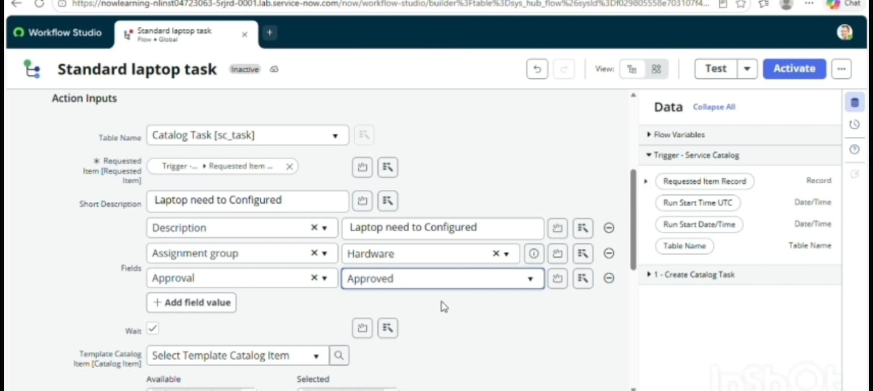

Milestone 2: Flow Assignment to Catalog Item
Activity 1: Flow Assignment to Standard Laptop Service Catalog.

Steps Followed:
- Open ServiceNow and search for 'Maintain Items'.
- Select the record named 'Standard Laptop'.
- Navigate to the 'Process Engine' tab.
- Remove any legacy workflows and select the newly created flow 'Standard Laptop task' under the Flow field.
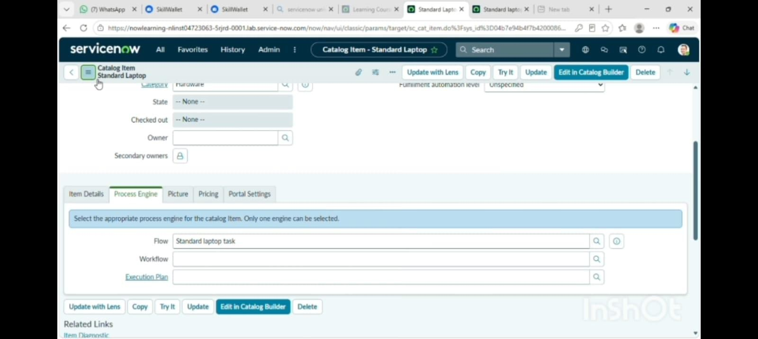
- Click Update to save the catalog item configuration.

Milestone 3: Service Catalog Order & Task Execution
Activity 1: Service Catalog Ordering, Approval, and Task Generation.

Steps Followed:
- Navigate to Service Catalog > Hardware > Standard Laptop (Lenovo Carbon x1).
- Click 'Order Now' to submit the request, generating a Request number (e.g., REQ0010001).
- Open the Request record, navigate to the Approvers related list, right-click, and select 'Approve'.
- Open the generated Requested Item (RITM) and verify that the Flow Designer successfully triggered and created the Catalog Task (SCTASK).
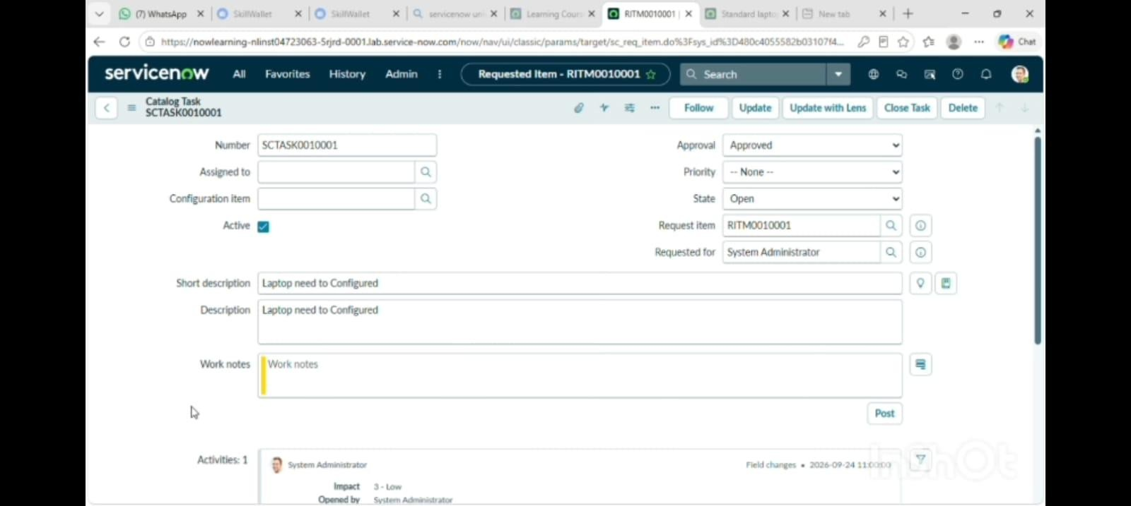
- Open the Catalog Task record to verify the short description ('Laptop needs to Configured') and assignment group ('Hardware').

Conclusion
By automating the standard laptop procurement process with ServiceNow's Flow Designer, the project effectively addresses inefficiencies and reduces manual overhead. This streamlined workflow ensures timely configuration of laptops, minimizes user wait times, and enhances overall productivity within the IT department. The implementation of this automated solution not only optimizes resource allocation but also significantly improves the user experience by providing a seamless and efficient procurement process.

